What is Docker Volume | How to Create Volumes | Docker Storage | Docker Volume

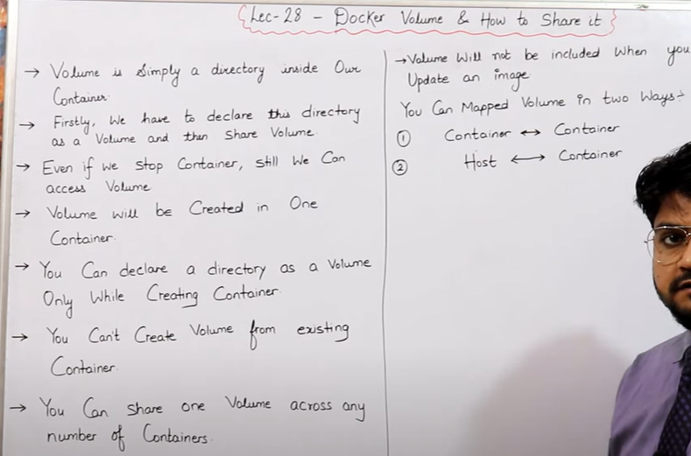

* Hum apane container kein andar kisi bhi eak directory ko volume bana dete hai, Phir vo normal directory nahi rehati vo volume directory ban jati hai.
* We declare directory as a volume after declare volume we have a option to share volume with anyone.
* We can share a volume Container to Container and Host to Container .
* Hum volume ko hardum container create karane sein pehale hi banate hai running container mein hum volume nahi bana sakte .
* Volume ko hum bahut logo kein sath share kar sakte hai , for example mene volume banaya us volume ko mein multiple user ko de sakta hu, aur user agar volume mein kuch change karta hai toh vo sab ko dikhega jitane logo kein pass volume share hai, but agar volume delete karta ai user toh vo volume kewal apane container kein andar sein user delete kar payega baki sab kein container mein volume show hoga.

Benefits of Volume

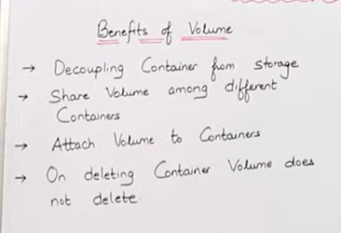

* Container kein delete hojane par bhi humara data delete nahi hota jo volume mein data pada hai vo pada rehata hai.
* Hum apane volume ko multiple account kein sath share kar sakte hai
* Hum jab docker file likhate hai uske andar hi hum volume ko define kar dete hai. Running container mein hum volume nahi bana sakte

**Create docker volume**

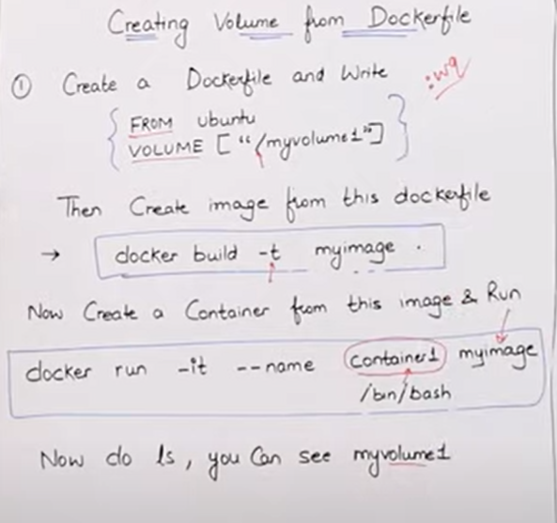

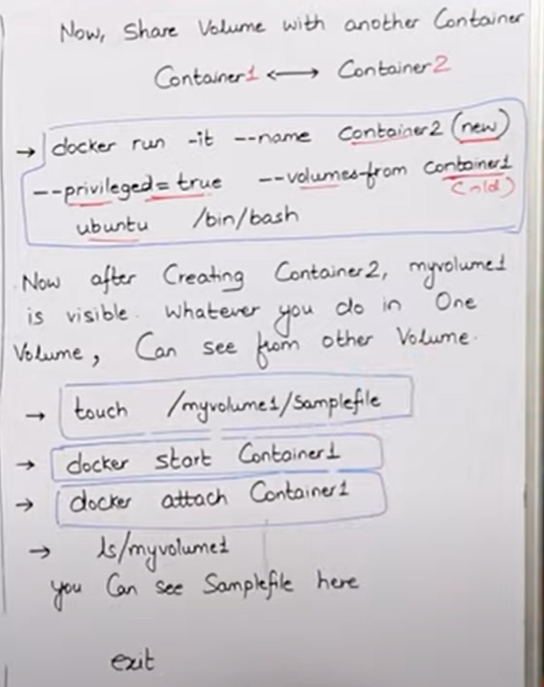

* Hum container banana sein pehale hi volume apane file mein define karate hai aur agar hum apani volume kisi kein sath share bhi karna chahate hai toh bhi container run karane sein pehale hi docker file mein likhana padta hai, ki um kiske sath apani volume share kar rahe hai mera matlab kis container kein sath.
* Lets see agar mene koi volume banayi apane container 1 mein aur jiska naam satyam hai aur vahi volume mene share kiya container 2 aur container 3 kein sath toh unke bhi vaha satyam volume show hoga, aur agar container 2 aur container3 nein volume mein kuch changes kiye toh vo sabhi container kein volume mein show hoga kyu ki ye common volume rahegi jisko share karoge aap, aur agar unme sein kisi bande nein volume delete kar di toh vo kewal apane container kein andar sein volume delete kar payega baki sab container mein humari volume rahegi.

**DOCKER VOLUME CREATE**

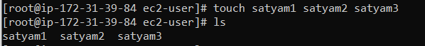



* Save docker file,
* Yaha mene eak directory ko volume naam sein define kar diya hai, aur ab vo humari volume directory ban gayi.

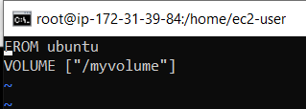

* Convert docker file to docker image, and we step-2 is making a volume

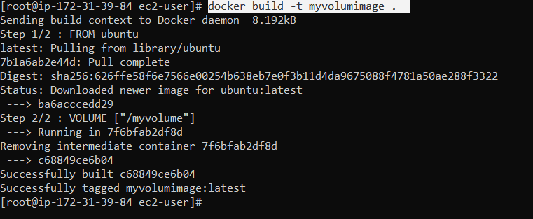

* One operating system image & one volume image

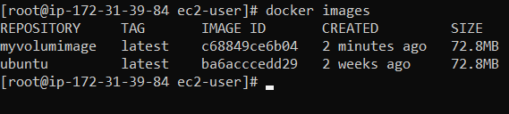

* Convert image to container



* Now our volume directory is visible.

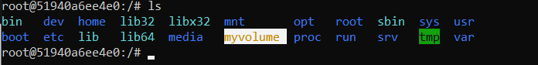

* Create a file in volume directory

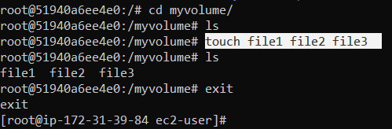

**Share container volume to other container**

* Mene eak naya container banaya aur us container kein andar mene apane peechale container ki volume ko share kar diya.
* Pehale mene container 3 naam sen eak container banaya then uske baad mene container 1 ki volume ko container 3 kein andar share kar diya.
* **Privileged =true** ka matlab hai ki jiske sath bhi hum apani volume directory share kar rahe usko hum sab permission de rahe ki bhai tum jo chaho changes kar sakte ho volume directory kein andar .
* 
* 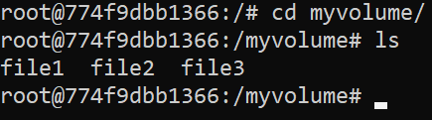
* Now we add some file in our container3, & we see our container1 is also been updated .
* Agar mene container3 mein koi file add kiya hai toh vo file muje container3 mein bhi show hogi jis- jis container kein andar mene vo volume directory share kiya hoga vo sab container mein mujhe changes dikhega .

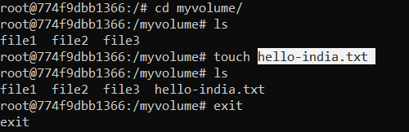

* Now we go to container1 and check volume directory , hum container3 kein directory mein jo kaam kiya hai vo mere container1 mein bhi dikh raha hai .

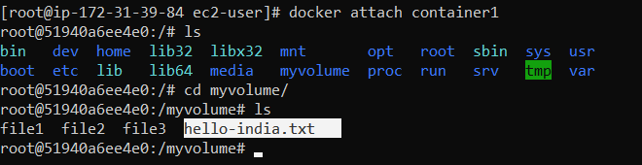

* If we want to create a volume using command we use this command.
* Agar hum volume ko bina docker file image kein andar likhe create karna chahate hai toh uske liye hum ye command use karenge iss command sein humara naya container bhi ban jayega aur us container kein andar hum apani volume directory bhi create kar denge , for example agar hum dekhe toh humane satyam-volume2 kein naam sein apani volume directory create kari hai .
* Command mein **-v** isliye hi likha hai mene ki ki jab mera naya container bane toh usme **satyam-volume-2** naam sein eak volume directory bhi create kar dena.

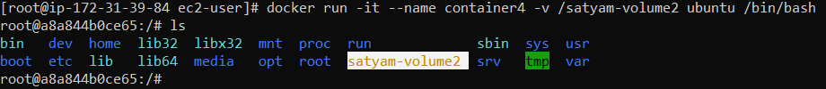

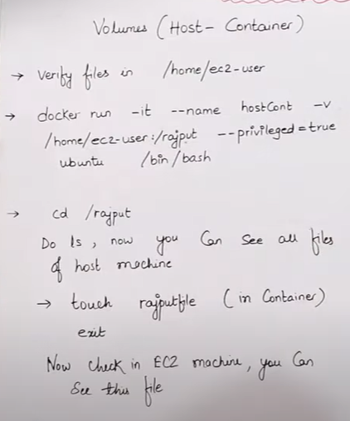

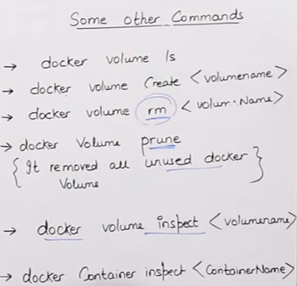

* **docker volume ls**

humare jitane bhi volume hai sab show ho jayegi

* **docker volume prune**

humari koi bhi volume jo kahi use nahi ho rahi hai usko yein delete kar deta hai

* **docker volume inspect <volume name>**

humare volume sein kya-kya juda hai vo puri detail miljayegi is command sein.

* **docker container inspect <container name>**

hum agar apane container sein judi cheeje janana chahate hai toh ye use karenge .

**Maping**

* Maping ka kaam hota hai ki jo bhi humare user kein andar file padi hai us file ko container kein andar volume mein daal do aur jab bhi container kein volume mein kuch changes hogi toh vo humare user kein andar bhi dikhegi.
* Agar mere kisi user kein andar file padi hai aur us file ko mein apane new container kein andar new volume define karke uske andar le jana chah raha toh mein ye karunga.
* Humare ec2- user kein andar kuch file padi hai ab is file ko mein chahata hi new container bana kein uske andar volume banau aur ye file us volume mein bhi copy hojaye

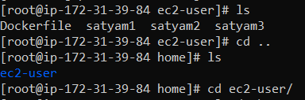

* hostname mere new container ka naam hai, ec2-user apane user ka naam diya hai ki is user kein andar jo file padi hai us file kein uthaa kein new volume create kar do eak new container kein andar

s

* Hum dekh sakte hai humara volume create ho gaya hai aur us volume kein andar hum jaake dekhenge toh vo sab file aagayi jo humare user kein pass thii.

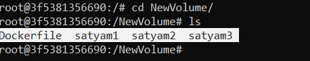

* Abhi mere user kein andar kewal itani hi file hai



* Agar mene apane container kein volume kein andar new file banayi hai toh vo mere user kein andar bhi dikhega.

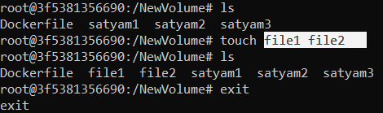

* Humare user kein andar file1 aur file2 dikhene lagi

